Ac Circuits Lab 4 Michael Sarlo Lennon

Figure 1a

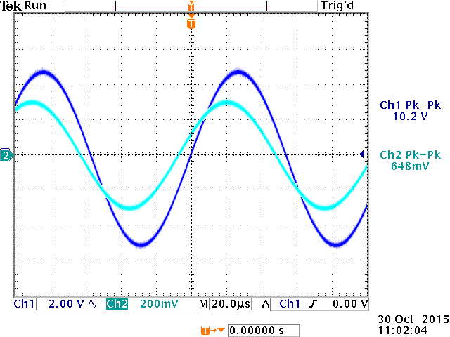

Parallel Figure 1a:

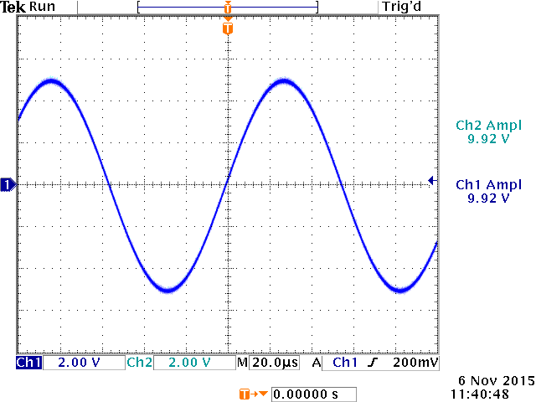  
Note: There is one wave form because the two waves were identical

Figure 1b

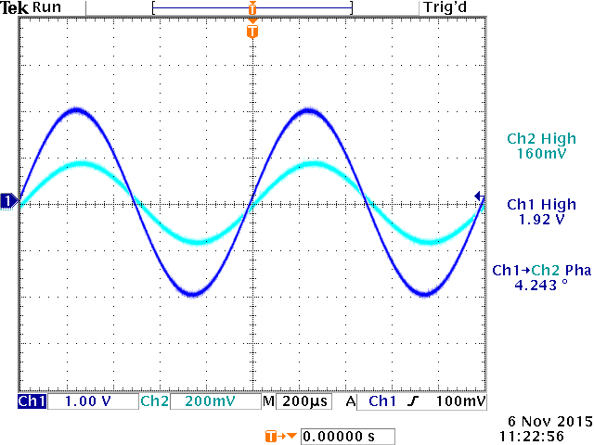

Parallel Figure 1b

